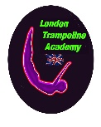
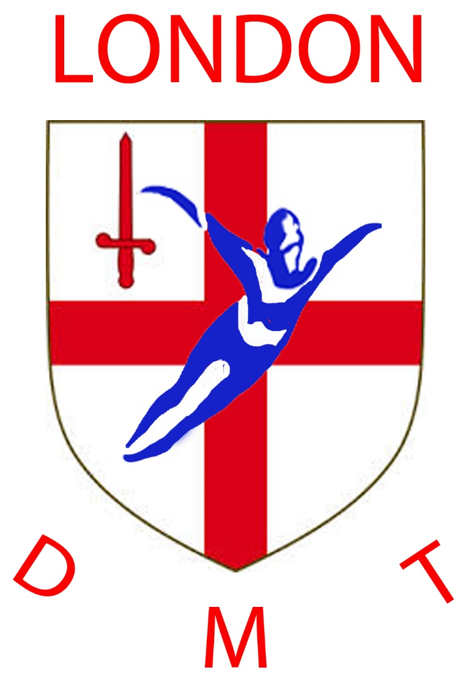

Welcome to London Trampoline Academy/London DMT at Reynolds Sports Centre, Acton High School
Gunnersbury Lane, Acton W3 8EY.
Information for new parents and performers.
Welcome
London Trampoline Academy/London DMT is a friendly, nationally recognised and well respected private club. We have been in existence for over 37 years during which time we have been extremely successful locally, regionally and nationally. We cater for all ages and abilities (including adults, and participants with special needs). Numbers are limited to ensure every participant has the maximum opportunity to progress.
Our sessions are:
Monday Session 1 - 6-00-7.30 pm / Session 2 - 7.30-9 .00 pm
Tuesday Session 1 - 6-00-7.30 pm / Session 2 - 7.30-9 .00 pm (London DMT 6.30 – 8.30pm)
Thursday Session 1 - 6-00-7.30 pm / Session 2 – 7.30-9.00 pm (London DMT 6.30 – 8.30pm)
Saturday 10.00 – 12.00 (term Time only at present)

Fees structure:
Club membership is £20 per annum. Session fees are £28 per month per session (when paid by standing order) reduced for more than one session. Annual Club and British Gymnastics membership (combined) will be required (currently £37 p.a. Recreational/£50 p.a. Competitive).
Coaches:
We have some of the most experienced and highest qualified coaches in London. We have 100+ years coaching experience collectively. Please discus concerns with us but we are professional coaches who will always do/advise what is best for every individual gymnast in our care. Please treat us with respect.
Notes:
- We aim to have a maximum of 4 or 5 per trampoline.
- We aim to have a coach and/or senior national performer per trampoline.
- We will train 16+ members to do their coach and judge awards when they are ready.
- All Coaches are enhanced DBS checked.
- We have been recognised by British Gymnastics as a quality club by being awarded “GymMark”.
- We are a “not for profit” club. All of the income generated goes back into the club for hall hire, equipment, equipment maintenance, administration etc.
- We are a competitive club. There is an expectation that members will compete for the club when they are ready. This expectation only applies to under 16’s. Adults are free to jump competitively or recreationally as they wish. We compete in; London Regional events, National Elite events, National League events and International Club Invitational Events (mainly European and for senior grades) and local and national invitational competitions.
- We have had over 150 National Finalists (Trampoline, Synchro, Double Mini) in the past 10 years and numerous British champions and medallists.
- We are currently the most successful club in London at both Trampoline and Double Mini Trampoline (last three years 3 British Champions, 6 national medalists, 1 junior international, 2 GB world age trialists).
Policies
Application for membership signifies agreements to all club policies (available on the club website)

Further Information
John Wotherspoon /Sheila A’Bear (Chairmen), 28 Sandringham Road, Northolt, Middlesex, UB5 5HN
Telephone: 07950 267655

E-mail: info@londontrampoline.com.com Web: http://londontrampoline.com.com and www.londondmt.uk

